
New Research Study: Understanding American’s Evaluation of media
•Who: American, age 18+
•Where: 200 Murphy Hall
•When: February 3rd – 28th
Mondays 10:00 am - 1:00 pm Wednesdays 10:00 am - 1:00 pm* Thursdays 9:00-11:00 am and 12:30-2:30 pm
Fridays 9:00 am - 1:00**
•What: Watch a short video and answer questions (10 to 15 minutes) •Take part in a study and receive $5 in Gopher Gold or receive 2 extra credits for a JOUR course enrolled in the SONA system
The study is done by:
Dr. Claire M. Segijn, assistant professor at HSJMC, University of Minnesota
Student researcher: Gwiwon (Jason) Nam
content
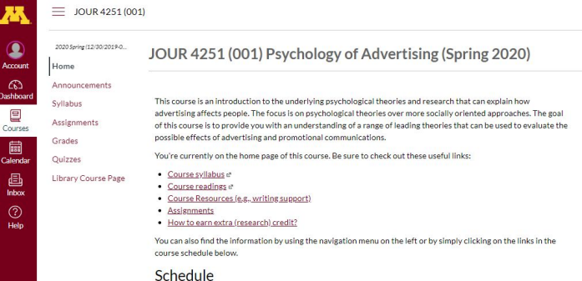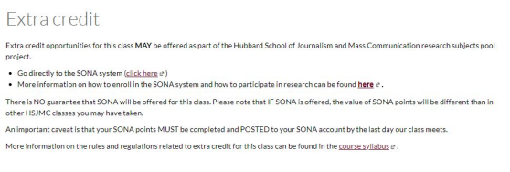
JOUR 4251
Psychology of Advertising 3.1 Attention, perception, processing (Continued)
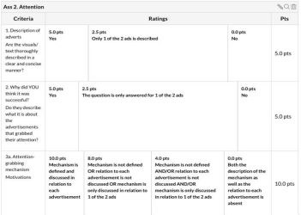
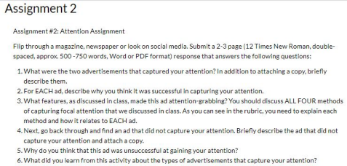Questions?
Check grading rubric before submitting!!!
Use subheadings and paragraphs, to clearly
indicate what question you are answering.
Follow guidelines to get all the points.
NOTE 3 ads in total:
● 2 successful at grabbing your attention
● 1 unsuccessful at grabbing your attention
Reading responses (good examples)
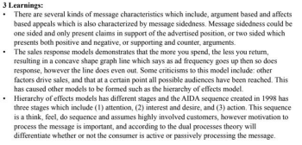
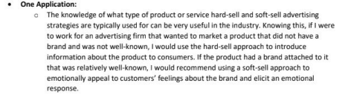
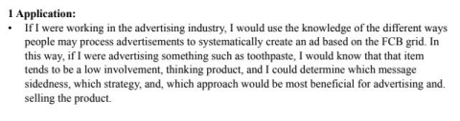
Recap Thursday
● Preattentive analysis
○ Feature analysis vs. semantic analysis ○ Hedonic fluency
■ Perceptual
■ Conceptual
○ Matching Activation Hypothesis ● Focal attention
○ Motivation (goal)
○ Salience
○ Vividness
○ Novelty
Preattentive analysis Focal attention Comprehension Elaborative reasoning
Stages of processing
1. Preattentive analysis
2. Focal Attention
3. Comprehension
4. Elaborative Reasoning
Preattentive analysis Focal attention Comprehension Elaborative reasoning
How do we consciously process?
Categorize
● Based on existing schemas (what we already know about the world) ● Based on information provided
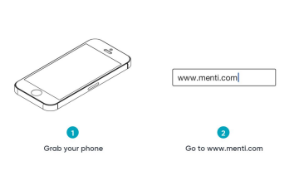
Enter the first word that
comes to mind when you
see the target word
Preattentive analysis Focal attention Comprehension Elaborative reasoning
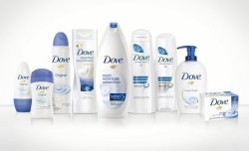
Categorization
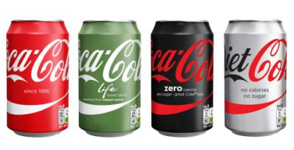
● Car?
● Luxury Item? ● Transportation?
Brand line or product extensions When they diversify the product line
Quickly categorized
Not plain coke, but like coke
Success depends on congruence with parent brand or key associations
Preattentive analysis Focal attention Comprehension Elaborative reasoningCategorization 
Representativeness heuristic
Extent to which two stimuli are deemed to belong to the same overall category based on shared characteristics
Preattentive analysis Focal attention Comprehension Elaborative reasoning
Pioneering advantage
Being first results in some advantages for future brands:
1) Novel & interesting
2) Define category
3) Direction-of-comparison effect
Preattentive analysis Focal attention Comprehension Elaborative reasoning
Categorization is NOT just where something fits
^{It affects our opinions} Toaster A: lots of features, high end Toaster B: Fewer features, low end
Which is rated higher?
Depends on whether you
highlight the common brand.
Preattentive analysis Focal attention Comprehension Elaborative reasoning
Categorization
Assimilation
The product is associated as MORE similar than it really is to the parent category
Contrast
The product is DIFFERENTIATED from the parent company
Preattentive analysis Focal attention Comprehension Elaborative reasoning
Example
Preattentive analysis Focal attention Comprehension Elaborative reasoning
Brand personality
Preattentive analysis Focal attention Comprehension Elaborative reasoning
Stimulus based impression formation
1. Show people images of people wearing 2 brands (Hugo Boss and Australian). In context and not in context.
2. Hugo boss in golf course; Australian in campsite
3. Rated the people wearing the clothes in competence the same way they rated the brand. Especially when the Hugo Boss was in golf course and Australian in campsite
4. Put them under a time crunch... Then, ONLY the brand, not the context guided the impressions
Preattentive analysis Focal attention Comprehension Elaborative reasoning
Stages of processing
1. Preattentive analysis
2. Focal Attention
3. Comprehension
4. Elaborative Reasoning
Preattentive analysis Focal attention Comprehension Elaborative reasoning
Comprehension
Do you generally understand advertisements?
Can you think of a time you didn’t understand an advertisement?
Preattentive analysis Focal attention Comprehension Elaborative reasoning
Comprehension
● 80% of advertisements are misunderstood in some way
● Truth effect: We accept information, even if we don’t quite understand it. Harder to reject than accept a claim. Takes more work.
● Sleeper effect: The more you see/hear a claim, the more true it seems. It’s familiar, and you just assume it’s true.
● Inferences: We fill in the blanks. Comparisons are not always clear.
Preattentive analysis Focal attention Comprehension Elaborative reasoning
Preattentive analysis Focal attention Comprehension Elaborative reasoning
Strategies to muddy comprehension
Omit comparisons: “Dentists recommend Trident” => Over what? Eating chocolate bars?
Pragmatic inferences: “Brand X may be the best beer in the world” => well yeah, and Brand X may also be the worst. It isn’t false, but it isn’t maybe true.
Juxtaposition: “Be cool, buy brand X” => suggest a causal relationship (A=B)
Affirmation of the consequent: “if you can see it, you can make it: Brand X” => reverse cause and effect (B => A vs. A => B)
Preattentive analysis Focal attention Comprehension Elaborative reasoning
Preattentive analysis Focal attention Comprehension Elaborative reasoning
Stages of processing
1. Preattentive analysis
2. Focal Attention
3. Comprehension
4. Elaborative Reasoning
Preattentive analysis Focal attention Comprehension Elaborative reasoning
Elaborative reasoning
HIGH involvement (motivated!)
Process by which the advertisement is actively related to previously stored knowledge and allows for simple OR more complex inferences.
THINKING
● Extent of the thinking - How much?
● Valence of the thinking - how positive?
● Object of the thinking - product, competitor?
Preattentive analysis Focal attention Comprehension Elaborative reasoning
Motivations to elaborate
SELF SCHEMA
“I am pro-environment!” Makes you motivated to process a message if it is about the environment
You process more elaboratively when the product message MATCHES your self-schema. “This is a message for me”.
Preattentive analysis Focal attention Comprehension Elaborative reasoning
Metacognition
Thinking about thinking
The person doesn’t think about the product, they think about themselves Think about their own judgment “am I falling for this?”
Self-validation: Consumers need confidence their decision is good.
What’s next?
● Submit reading response on Chapter 2
○ Due Feb 6 (Thursday) before class starts (2:30 pm)!
○ Hand in on Canvas: upload Word/PDF document
● Start reading Chapter 3 (after handing in reading response) ○ We will start talking about memory on Thursday
● Start making assignment 2 (attention)
○ Due Feb 13 before class starts!
○ Hand in on Canvas: Upload PDF document + photos/copies of the ads
● Let us know whether you need a laptop for Exam 1 (Feb 27) ○ Email your TA by Feb 13

